**THE DEMOGRAPHIC SITUATION AND THE LEVEL OF UNEMPLOYMENT   
IN POLAND IN THE YEARS 2002-2014**

**Abstract.** The demographic changes occurring in Poland since the 80s of the twentieth century clearly show the aging of the population, which the processes of fertility, mortality and migration have a huge impact. This phenomenon is a serious problem of demographic and socio-economic because it leads to many adverse consequences, ie. an increase in public expenditure, policy changes the functioning of social security, health and education, increased demand for care services, reducing pension benefits and social benefits, the retirement age, increase in unemployment, mass migration.

In the study will carry out spatial analysis of the demographic potential and the level of unemployment in Poland, and will research the impact of the level of unemployment on the process of aging society in Poland in the years 2002-2014.

**Keywords:** demographic potential, level of unemployment, Perkal synthetic indicator, spatial autocorrelation.

JEL: C49

**SYTUACJA DEMOGRAFICZNA A POZIOM BEZROBOCIA  
 W POLSCE W LATACH 2002-2014**

**Streszczenie.** Zachodzące od lat 80-tych XX wieku zmiany demograficzne w Polsce uwidoczniają wyraźny proces starzenia się społeczeństwa, na który ogromny wpływ mają procesy: rozrodczości, umieralności i migracji. Zjawisko to jest poważnym problemem demograficznym jak i społeczno-ekonomicznym, gdyż prowadzi do wielu niekorzystnych konsekwencji, tj. zwiększenie wydatków ze środków publicznych, zmian zasad funkcjonowania systemów zabezpieczenia społecznego, opieki zdrowotnej i szkolnictwa, zwiększenia popytu na usługi opiekuńcze, obniżenie świadczeń emerytalno-rentowych oraz zasiłków socjalnych, wydłużenie wieku emerytalnego, wzrostu stopy bezrobocia, masowej migracji zarobkowej.

W opracowaniu zostanie przeprowadzona analiza przestrzenna potencjału demograficznego oraz poziomu bezrobocia w Polsce, a także zostanie zbadany wpływ poziomu bezrobocia na proces starzenia się społeczeństwa Polski w latach 2002- 2014.

**Słowa kluczowe:** potencjał demograficzny, poziom bezrobocia, syntetyczny wskaźnik Perkala, autokorelacja przestrzenna.

JEL: C49

1. **INTRODUCTION**

The phenomenon of population aging is a serious demographic and also socio-economic problem. Observed since the 80s of the twentieth century the demographic changes in Poland show, how significantly changed and are still changing the age structure of Polish society. On the development of the phenomenon of population aging in Poland a huge impact have processes: fertility, mortality and migration. The progressive process of the population aging leads to many adverse consequences, e.g. an increase in public expenditure, the changes of rules of functioning the systems of social security, health and education, increased demand for the care services, reducing the pensions and social benefits, elongation the retirement age, increase in unemployment and mass migration.

Another important socio-economic problem is unemployment. The growing since 2009, the value of the unemployment rate in Poland is one of the most important and difficult to solve the problems of the Polish economy. It stems among other things from the economic transformations, increasing the technical and organizational progress in the sphere of production, the collapse of entire industries, as well as the lack of qualifications and work experience, low mobility of the population and the high cost of commuting. Due to the long-term nature of this phenomenon it can be observed negative effect on the standard of living of the population, on the dynamics of economic development and social moods.

The aim of the study is to analyze the spatial differentiation of dynamics of an aging population and the level of unemployment in counties in Poland and to study the relationship between the unemployment rate and the process of aging the Polish society. All calculations and maps were made in the statistical program R CRAN and Microsoft Excel. The data was obtained from the Local Data Bank of the Central Statistical Office, 2002-2014 [www 1].

**2. DEMOGRAPHIC CHANGES IN POLAND IN THE YEARS 2002-2014**

A complete image of changes in the number and structure of the population of Polish society can be seen based on the observations of real growth of population number and the indicators: total fertility rate and gross reproduction (since 1950, for these indicators can be observed a decreasing trend). In the period under consideration, i.e. in the years 2002 - 2014 the actual population growth in Poland, was stable and fluctuated around 0. Since 1950, the high value of total fertility rate (equal to 3.705) gradually decrease and in the analyzed period on average, stood at 1.294. This means that over 60 years, the number of born children per woman of childbearing age (15 - 49) decreased by 2.4. Similar conclusions can be drawn by observing the average number of female children born per woman which is currently of childbearing age, i.e. gross reproduction rate. Observed in the period 2002 - 2013 the low values of total fertility rate (less than 2.10) does not guarantee the replacement of generations [Miśkiewicz-Nawrocka 2015].

The most commonly used measures of describing the process of aging of the population are: the factor of demographic aging [Cieślak 1992], the index of demographic aging [Długosz 1998] and the load factor of demographic [Cieślak 1992]. The aging of the population in a certain period of time,can be also assessed by indicator of demographic aging, proposed by Z. Długosz [1998]. The estimated values of the above mentioned measures indicate aging of the Polish society for the period 2002-2014. This phenomenon is particularly clearly visible based on the increasing values of the index of demographic ageing. The largest percentage of elderly population, in each year of the analyzed period, characterized voivodships: Lodzkie and Swietokrzyskie, which greatly exceeds the value of measurement obtained for the whole country. In voivodships Masovian, Silesian, Lubusz, Podlachian and Opole the progress of the process of demographic aging was also higher than in Poland. The lowest values of demographic aging factor were obtained for the voivodship Warmian-Masurian. The highest increase in the percentage of elderly population in the years 2002 - 2014 were obtained for the voivodships Silesian and Opole and the lowest for the voivodship Masovian. The study shows that the most advanced development of the phenomenon of an aging population in the years 2002 - 2014 applies to voivodship Silesian, but from one year to another it is felt in every voivodship. Measures of population aging show the greatest progress of this process in voivodships Lodzkie, Swiętokrzyskie, Silesian and Opole and the lowest in Masovian and Warmian-Masurian [Miśkiewicz-Nawrocka 2015].

**3. PERKAL SYNTHETIC MEASURE**

One method of assessing the potential of the studied phenomenon (the level of development of the region) is a taxonomic method - method of Perkal, which based on the construction of synthetic measure *mi* [Parysek, Wojtasiewicz 1979]. This measure based on the presentation of the variability the group of traits in a set of different objects in one year.

The higher value of the synthetic indicator means better position the object in terms of level of development. Perkal indicator is estimated as the arithmetic mean of traits :

, , (1)

where:

*n* is the number of included features,

 is the standardized value of *j* - the features for the *i* - th object,

, when  is the value of stimulant, (2)

, when  is the value of anti-stimulant, (3)

 is the original value of *j* - the features for the *i* - th object,

 is the arithmetic mean value of *j* - the features,

 is the value of standard deviation of *j* - the features.

**4. SPATIAL STATISTICS**

There are two types of indicators of spatial associations (ISA): global and local measures of autocorrelation. The global autocorrelation follows from the existence of correlations across the spatial unit test. The local measure shows a spatial dependency the variable with neighboring units in a particular location. The most commonly used global and local measures are: the Moran statistics  [Moran 1950] and the Geary statistics  [Geary 1954], [Anselin 1995]. The spatial autocorrelation occurs when a certain phenomenon in a single spatial unit alters the probability of occurrence of this phenomenon in the neighboring units [Bivand 1980]. In general, the positive spatial autocorrelation occurs when we observe the accumulation, in terms of the location, high or low values ​​of observed variables. In the case of negative autocorrelation, high values ​​adjacent to low, and low to high, creating a kind of checkerboard [Suchecki 2010]. The lack of spatial autocorrelation means the spatial randomness, i.e. the high and low values ​​of observed variables are distributed independently.

## 4.1. GLOBAL STATISTICS

The Moran statistics is one of the most widely used measures in the study of spatial autocorrelation. The global Moran’s *I*  is defined as follows:

, (4)

where: ,  are the values ​​of variables in spatial unit *i* and *j*,  is the mean of variable for all units, *n* is the total number of spatial units that are included in the study,  is the sum of all elements of a spatial weight matrix, *z* is a column vector of elements , *W* is the spatial weight matrix degree *n*, defining the structure of the neighborhood,  is an element of weights matrix *W* [Kopczewska 2006]. This statistic takes values ranging from : positive, when tested objects are similar, negative, when there is no similarity between them and approximately equal to 0 for a random distribution of objects.

Cliff and Ord [Cliff, Ord 1973] have shown that the distribution of Moran statistics is asymptotically normal. Thus, the statistical significance of spatial autocorrelation can be verified using normalized statistics :

 , (5)

where:  is the expected value of Moran’s and  is its variance:

,  , (6)

 , , . (7)

If the Moran statistic has a value  it indicates a random spatial pattern. However, when  the spatial autocorrelations is positive, and if , the spatial autocorrelations is negative.

## 4.2. LOCAL STATISTICS

The Local Moran determines clusters of spatial units and studies whether the unit is surrounded by neighboring units with similar or different values ​​of the variable studied in relation to the random distribution of these values ​​in the studied space [Zeug – Żebro, Wolny – Dominiak 2012].

In the case of non-standardized values ​​of the variable and row-standardized spatial weight matrix [Arbia 2006] (), the local Moran is given by:

. (8)

where all elements of the formula are defined as in the Global Moran’s *I.* The standardized Local Moran’s is used to test the statistical significance of local spatial autocorrelation [Anselin 1995]:

 (9)

where:  is the expected value of the Local Moran and  is its variance

 i , (10)

where .

When  is negative, the spatial autocorrelation is negative too, i.e. when the object is surrounded by spatial units with significantly different values ​​of the studied variable. The spatial autocorrelation is positive when , the object is surrounded by similar neighboring units.

**5. THE EMPIRICAL ANALYSIS**

The object of the study were all Polish counties in 2002, 2008 and 2014. In the first stage of the study estimated a Perkal synthetic measure and tidied counties due to the level of the studied phenomenon, ie. the process of the society aging. Table 1 shows a set of diagnostic features taken into account in the study, assuming division between stimulants (S) and anti-stimulants (D)[1]. The selection of these variables resulted from the analysis of the factors determining the process of demographic change.

Table 1

Set of diagnostic variables

|  |  |  |
| --- | --- | --- |
| X1 | The population density - population per1 km2 | S |
| X2 | Feminisation factor - the number of women per 100 men | S |
| X3 | Demographic dependency ratio - the population of non-working age per 100 persons of working age | S |
| X4 | Demographic dependency ratio - the population of post-production age per 100 persons of pre-production age | S |
| X5 | Demographic dependency ratio - the population of post-production age per 100 persons of working age | S |
| X6 | Vital statistics - number of live births per 1000 population | D |
| X7 | Average monthly gross remuneration in relation to the national average | S |

Source: own elaboration.

In order to eliminate variables strongly correlated with other features, used the parametric method proposed by Z. Hellwig [1981]. Because the strongly correlated proved to be only variables X4 and X5 (in 2014), as a set of diagnostic features in the years 2002, 2008 and 2014 were taken into account all of the variables listed in table 1. In the next step of study, used a Perkal synthetic measure to ordering Polish counties due to the level of phenomenon of the aging population. Table 2 shows the counties for which the Perkal indicator was the biggest and the smallest in the years 2002, 2008 and 2014.

Table 2

Polish counties, for which the Perkal indicator reached 10 smallest and largest values in the years   
2002, 2008 and 2014.

|  |  |  |  |  |  |
| --- | --- | --- | --- | --- | --- |
| 2002 | | 2008 | | 2014 | |
| max | min | max | min | max | min |
| Warszawa | Zory | Sopot | Zory | chojnicki | nowodworski  (Pomeranian) |
| Sopot | braniewski | Warszawa | kartuski | Lodz | grodziski  (Greater Poland) |
| Lodz | bytowski | Lodz | slupski | Warszawa | kartuski |
| hajnowski | slupski | Katowice | grodziski  (Greater Poland) | Katowice | bytowski |
| Katowice | olsztynski | hajnowski | torunski | hajnowski | pszczynski |
| Poznan | nowodworski  (Pomeranian) | Chorzow | wejherowski | Sopot | Bydgoszcz |
| Chorzow | wejherowski | bielski  (Podlachian) | obornicki | Jelenia Gora | leborski |
| Krakow | wolsztynski | Krakow | gdanski | Jastrzebie Zdroj | nowosadecki |
| Jelenia Gora | gdanski | Poznan | bytowski | Kalisz | koszalinski |
| bielski  (Podlachian) | głogowski | Gdansk | grudziadzki | Sosnowiec | limanowski |

Source: own elaboration.

Based on the estimated values of the Perkal indicator it can be concluded, that the most advanced aging of the population (the first 10 positions in the ranking) in the analyzed period occurs in Warszawa, Sopot, Lodz and Katowice and the county hojnowski. The most favorable situation can be noted in Zory and in counties Slupsk, Wejherowo, Nowy Dwor, Gdansk, Grodzisk, which in years 2002, 2008 and 2014 occupied the last positions in the rankings.

Analyzing the dynamics of an aging population in the years 2002-2014 it can be seen, that the greatest changes "in favor" (a decrease of approximately 320 -260 positions) were recorded in the counties Bydgoszcz, Gdansk, Slupsk, Olsztyn, and the least favorable change in ranking (increase about 220 items) apply to counties milicki, kwidzynski, bydgoski, Jastrzebie Zdroj and elcki. The smallest change in positions in the ranking in 2014 compared to 2002 can be observed in cunties brzezinski (decrease by 3 positions), opoczynski (an increase of 3 positions), ciechanowski (position unchanged), Capital City Warsaw (an increase of 2 items), wyszkowskim (an increase of 2 items), zurominski (an increase of   
1 items), gliwicki (an increase of 3 positions), Czestochowa (an increase of 1 items), Jaworzno (a decrease of 1 items), Katowice (a decrease of 1 items), zawiercianski (a decrease of 1 items), janowski (a decrease of 1 items), lukowski (an increase of 2 items), jaroslawski   
(a decrease of 2 positions), ropczycko-sedziszowskim (decrease by 3 positions), hajnowski (an increase of 1 items), slupeckim (decrease by 3 positions), policki (a decrease of 1 items), Jelenia Gora (a decrease of 2 positions), sredzki (decrease by 3 positions) and oleski (an increase of 1 items). Moreover, given 2008 in compared the counties Warszawa, Czestochowa, Katowice and counties jaroslawski, hajnowski, slupecki, policki characterized by a stable situation (changes 2-3 positions).

In order to compare the Polish counties due to the development level of an aging population with unemployment, average monthly unemployment rates in counties in 2002, 2008 and 2014 were estimated. Table 3 shows the counties for which the average monthly unemployment rates were the biggest and the smallest in those years.

Table 3

Polish counties, for which the unemployment rate reached 10 smallest and largest values in the years   
2002, 2008 and 2014.

|  |  |  |  |  |  |
| --- | --- | --- | --- | --- | --- |
| 2002 | | 2008 | | 2014 | |
| max | min | max | min | max | min |
| ketrzynski | siedlecki | zarski | Swinoujscie | zarski | polkowicki |
| koscierski | zarski | zninski | siedlecki | starogardzki | Jaworzno |
| opolski  (Lublin) | wagrowiecki | bytowski | wyszkowski | bytowski | siedlecki |
| szczycienski | polkowicki | wejherowski | Koszalin | leborski | zabkowicki |
| wejherowski | Jaworzno | tczewski | polkowicki | sulecinski | glogowski |
| policki | Swinoujscie | sulecinski | ostrowiecki | tczewski | wyszkowski |
| braniewski | gorzowski | starogardzki | lobeski | zninski | otwocki |
| zninski | Koszalin | stalowowolski | otwocki | wejherowski | kedzierzynsko-kozielski |
| bialostocki | skierniewicki | ketrzynski | Jaworzno | policki | Swinoujscie |
| szczecinecki | ostrzeszowski | szczycienski | zabkowicki | opolski  (Lublin) | ostrowiecki |

Source: own elaboration.

On the basis of data in Table 3 it can be concluded, that the highest unemployment rates (first 10 positions in the ranking) in the years 2002, 2008 and 2014 are in the counties: wejherowski, policki, ketrzynski, opolski, starogardzki i zninski. The most favorable situation (the lowest unemployment rate) can be noted in the counties: Swinoujscie, Jaworzno, Koszalin, ostrowiecki, ostrowski, polkowicki, siedlecki, wyszkowski and ząbkowicki, which in the analyzed period occupied the last 10 positions in the ranking. The biggest change is characterized by the zarski county, which had one of the lowest unemployment rates in 2002 and one of the highest in the years 2008 and 2014.

Analyzing the dynamics of unemployment rates in the years 2002-2014 it can be seen, that the greatest changes "in favor" (a decrease of about 200 positions in the ranking) was obtained in the counties: zlotoryjski, zaganski, krosnienski, ostrowiecki and kwidzynski. On the other hand, the least favorable changes relate to the zarski county (an increase about 374 positions in the ranking) and counties sulecinski and pinczowski (an increase of 300 positions in the ranking). The smallest changes in positions in the ranking in 2014 compared to 2002, can be observed in the counties: laski (a decrease of 2 positions), lowicki (a decrease of   
2 positions), wieruszowski (decrease by 3 positions), grojecki (a decrease of 2 positions), siedlecki (an increase of 2 positions), bedzinski (an increase of 1 position), czestochowski (unchanged), Jaworzno (decrease by 3 positions), Zory (an increase of 1 position), radzynski (unchanged), nowosolski (an increase of 1 position) , nowotomyski (decrease by 3 positions), Swinoujscie (an increase of 3 positions), policki (decrease by 3 positions), polkowicki (decrease by 3 positions), nyski (a decrease of 1 position), zninski (an increase of 1 position) wejherowski (a decrease of 3 positions), bartoszycki (a decrease of 2 positions), ilawski   
(a decrease of 1 positions). Moreover, given 2008 in compared the counties of Siedlce, Gliwice, Polkowice, wejherowski, bartoszycki characterized by a stable situation (changes 2-3 positions).

The spatial relationship between the unemployment rate and the advancement of population aging process on the basis of estimated Perkal measure and the unemployment rates were examined by making a division of Polish counties into homogeneous groups, due to the level of studied phenomena advancement. The total interval of measures variability were divided into four classes, to which counties are assigned according to the following rules [Kuc 2012; Zeliaś 2000]:

* class I (high levels of the studied phenomenon): 
* class II (medium levels of the studied phenomenon): 
* class III (low levels of the studied phenomenon): 
* class IV (very low levels of the studied phenomenon): 

where: , .

The results of obtained classes spatial distribution for Polish territorial division into counties in 2002, 2008, 2014 is shown in the following maps (Fig. 1). Maps (a), (c) and (e) show a breakdown due to the level of population aging expressed by Perkal synthetic measure, and the maps (b), (d) and (f) - due to the unemployment rate.

(a) 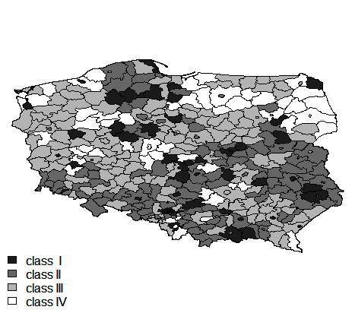 (b) 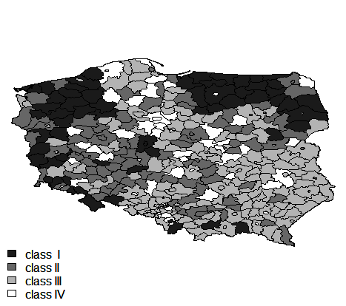

(c) 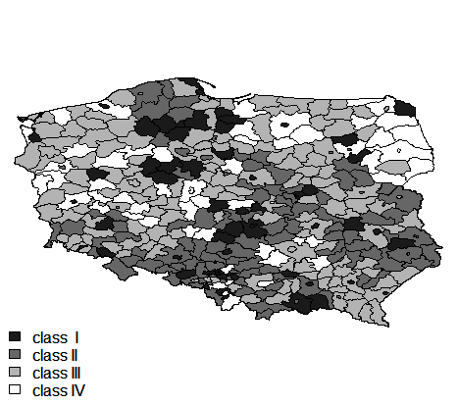 (d) 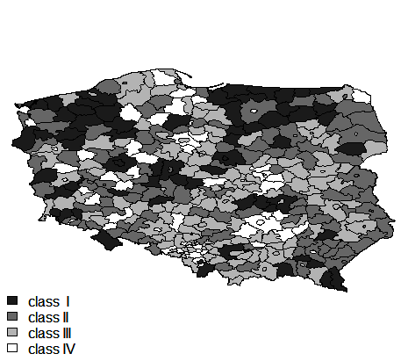

(e) 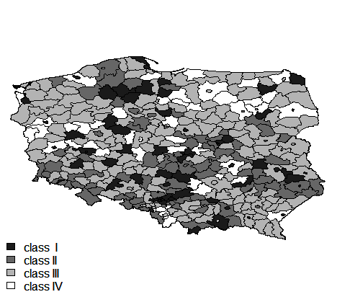 (f) 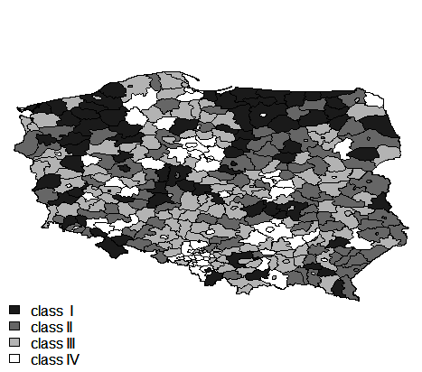

Fig. 1. The classification of counties Polish due to the value of the Perkal synthetic measure in years: (a) 2002, (c), 2008 (e) 2014 and of the unemployment rate in years: (b) 2002, (d), 2008 (f) 2014 .

Source: own elaboration.

Analyzing these maps it can be noted that in the years 2002, 2008 and 2014, most of the counties that belonged to the group I or II due to the value of unemployment rate were in a group IV or III due to the level of aging process advancement. Similarly, most of the counties belonging to the group III or IV due to the value of unemployment rate were in group I or II due to the level of aging process advancement. This means, that there is a correlation between the level of unemployment and the level of aging population advancement in the counties of Poland.

On negative correlation between the studied variables, i.e. unemployment and the advancement of population aging process, also indicate estimated Spearman’s correlation coefficients, which in the years 2002, 2008 and 2014 were respectively equal to -0.44, -0.31 and -0.23. However, the strength of this correlation is weak.

In the next stage we examined the spatial autocorrelation of Polish society aging process and the level of unemployment expressed by the rate of unemployment. Calculated values   
of global Moran are presented in Tables 4 and 5.

Table 4

Global Moran for the Perkal indicator in the years 2002, 2008 and 2014

|  |  |  |  |  |
| --- | --- | --- | --- | --- |
| Year | *I* | E(*I*) | Var(*I*) | *p*-value |
| 2002 | 0.2315 | -0.0027 | 0.0012 | 3.114·10-12 |
| 2008 | 0.1782 | -0.0027 | 0.0012 | 5.588·10-8 |
| 2014 | 0.1531 | -0.0027 | 0.0012 | 2.482·10-6 |

Source: own elaboration.

Table 5

Global Moran for the unemployment rate in the years 2002, 2008 and 2014

|  |  |  |  |  |
| --- | --- | --- | --- | --- |
| Year | *I* | E(*I*) | Var(*I*) | *p*-value |
| 2002 | 0.3861 | -0.0027 | 0.0012 | 2.2·10-16 |
| 2008 | 0.3032 | -0.0027 | 0.0012 | 2.2·10-16 |
| 2014 | 0.2880 | -0.0027 | 0.0012 | 2.2·10-16 |

Source: own elaboration.

Analyzing the data contained in Tables 4 and 5, it can be concluded that the global Moran are positive and statistically significant. This means the similarity of spatial units (counties) due to the level of advancement of population aging process and the unemployment rate.

The next stage of research was to estimate the local Moran in order to identify the spatial structure. The results of spatial distribution for the Polish counties in the years 2002, 2008, 2014 are shown in the following maps (Fig. 2).

(a) 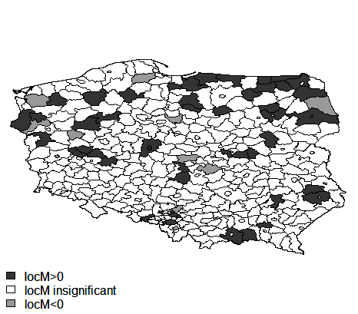 (b) 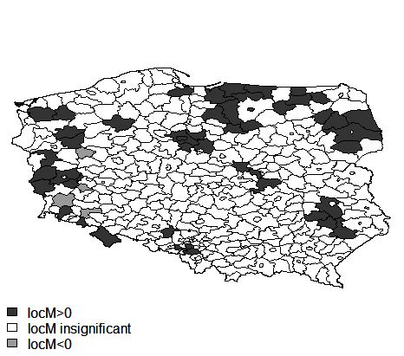

(c) 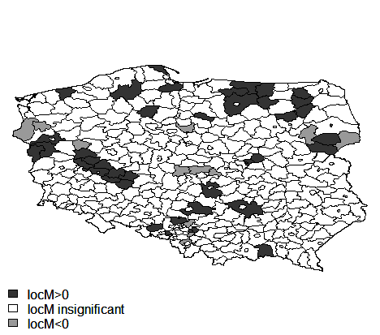 (d) 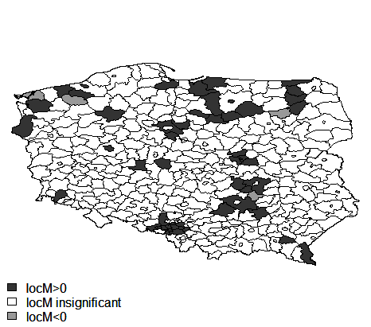

(e) 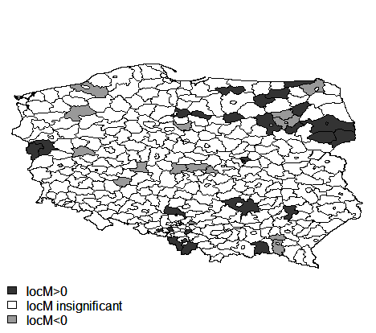 (f) 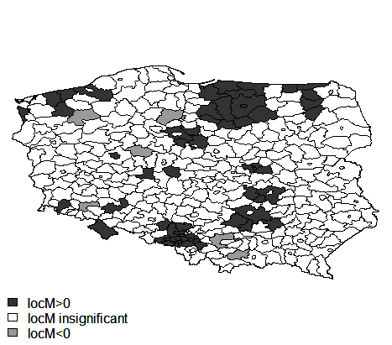

Fig. 2. The classification of counties of Poland due to the value of the local Moran for Perkal synthetic measure in years: (a) 2002, (c) 2008, (e) in 2014 and for the unemployment rate in years: (b) 2002, (d), 2008 (f ) in 2014.

Source: own elaboration.

On the basis of above maps (Fig. 2) it can be seen that only some of the local Moran are statistically significant. In the studied period, significant and positive values of local Moran obtained for the Perkal measure only for 56 counties in 2002, 44 counties in 2008, 34 counties in 2014 and for the unemployment rate only for 64 counties in 2002, 59 counties in 2008, 68 counties in 2014. This means that in chosen years, these counties have been surrounded by counties with similar values studied synthetic variable expressing the level of an aging population. Therefore, the above-mentioned counties have been clusters.

The local Moran statistic is statistically significant and less than zero for the Perkal measure for 11 counties in 2002, 13 counties in 2008, 16 counties in 2014 and for the unemployment rate for the 4 counties in 2002, 4 in 2008, counties, 7 counties in 2014. This means that in chosen years these counties have been called local outliers, because they have been surrounded by counties with a relatively lower level of aging process advancement.

For other counties Local Moran was statistically insignificant.

**6. CONCLUSIONS**

The study analyzed the demographic situation and the level of unemployment in the counties of Poland and also researched the spatial correlation of these two phenomena. Based on conducted research it can be concluded, that in the years 2002, 2008 and 2014 almost all of the counties were characterized by changes in the level of demographic potential and level of unemployment. The Classification of counties due to the estimated measure of Perkal and unemployment rate, showed that there is a correlation between the level of unemployment and the level of population aging advancement in the Polish counties. Most of the counties, for which the level of population aging advancement process was medium or high characterized by low unemployment, and vice versa, most of the counties, for which the level of population aging advancement process was low or medium characterized by high levels of unemployment.

The conducted analysis of spatial correlation of the demographic situation in the Polish counties based on local statistics Moran, indicated the existence of positive and negative spatial autocorrelation, that is, the formation of territorial units clusters with similar values of demographic potential level and outliers (ie. counties surrounded by units of relatively lower level of studied phenomenon).

**REFERENCES**

Anselin, L. (1995), *Local Indicators of Spatial Association*-LISA. Geographical Analysis, 27, p. 93-115.

Arbia, G. (2006), *Spatial Econometrics: Statistical Foundations and Applications to Regional Growth Convergence.* Springer, New York.

Bivand, R. (1980), Autokorelacja przestrzenna a metody analizy statystycznej w geografii. [In:] Chojnacki Z. (ed.) *Analiza regresji geografii*, PWN, Poznań, p. 23-38.

Cieślak, M. (1992), *Demografia. Metody analizy i prognozowania*. Wydawnictwo Naukowe PWN, Warszawa. Cliff A.D., Ord J.K. (1973), *Spatial Autocorrelation*. Pion, London.

Długosz, Z. (1998), *Próba określenia zmian starości demograficznej Polski w ujęciu przestrzennym*, [In:] Wiadomości Statystyczne, nr 3.

Geary, R. (1954), *The Contiguity Ratio and Statistical Mapping*. The Incorporated Statistician, 5, p. 115–145.

Griffith, D.A.(2003), *Spatial Autocorrelations and Spatial Filtering*. Springer, Berlin-Heidelberg.

Hellwig, Z. (1981), *Wielowymiarowa analiza porównawcza i jej zastosowanie w badaniach wielocechowych obiektów gospodarczych*, [In:] Welfe W. (ed.) *Metody i modele ekonomiczno-matematyczne   
w doskonaleniu zarządzania gospodarką socjalistyczną*, PWE, Warszawa, p. 46–68.

Kopczewska, K. (2006), *Ekonometria* *i statystyka przestrzenna z wykorzystaniem programu* R CRAN. Cedewu.pl, Warszawa.

Kuc, M. (2012), *The implementation of synthetic variable for constructing the standard of living measure in European Union countries*, Oeconomia Copernicana nr 3, Polskie Towarzystwo Ekonomiczne Oddział   
w Toruniu, p. 5-19.

Miśkiewicz-Nawrocka, M. (2015), *Analiza porównawcza czynników wpływających na zmiany demograficzne   
w Polsce w latach 2002-2013*, [In:] Mika J., Miśkiewicz-Nawrocka M. (eds.) *Metody i modele analiz ilościowych w ekonomii i zarządzaniu*, część 7, Wydawnictwo UE w Katowicach, Katowice, p. 34-58.

Moran, P. A. P. (1950), *Notes on Continuous Stochastic Phenomena*. Biometrika 37 (1), p. 17–23.

Parysek, J. J., Wojtasiewicz, L. (1979), *Metody analizy regionalnej i metody planowania regionalnego*, Studia KPZK PAN, Tom LXIX.

Suchecki B. (ed.) (2010), *Ekonometria przestrzenna. Metody i modele analizy danych przestrzennych*. Wydawnictwo C.H. Beck, Warszawa.

Zeliaś, A. (ed.) (2000), *Taksonomiczna analiza przestrzennego zróżnicowania poziomu życia w Polsce w ujęciu dynamicznym*, Wydawnictwo Akademii Ekonomicznej, Kraków.

Zeug-Żebro, K., Wolny-Dominiak, A. (2012), *Spatial statistics in the analysis of county budget incomes in Poland with the R CRAN*, [In:] Ramik J., Stavárek D. (eds.) *Proceedings of 30th International Conference Mathematical Methods in Economics.* Karviná: Silesian University, School of Business Administration, 2012, p. 992-998, ISBN 978-80-7248-779-0.

[www 1] [www.stat.gov.pl](http://www.stat.gov.pl)

1. Division of diagnostic features was based on the correlation coefficient calculated between the variables and the index of demographic ageing.