Tab. 1 Standardized death rates of diseases of affluence, average 2008-2010, and GDP per active population, 2008, by region of residence, by deciles
Diabetes mellitus | Diseases of the respiratory system | Neoplasms
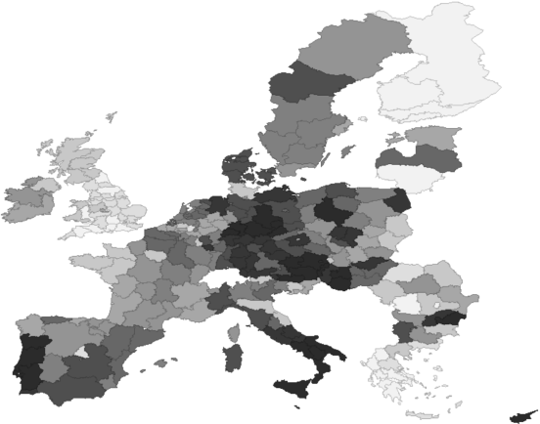 | 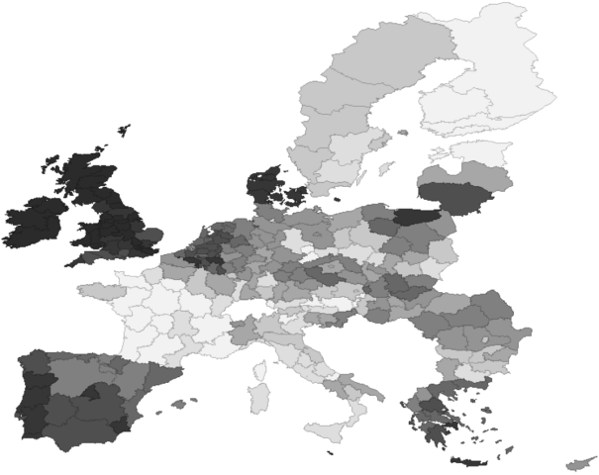 | 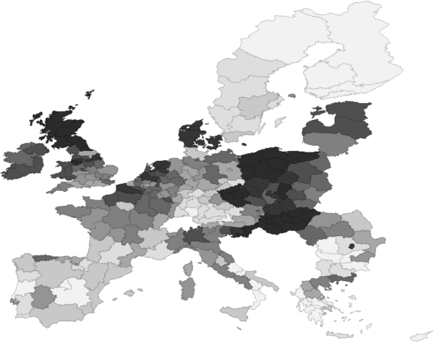
Diseases of the circulatory system | Mental and behavioural disorders | GDP per active population
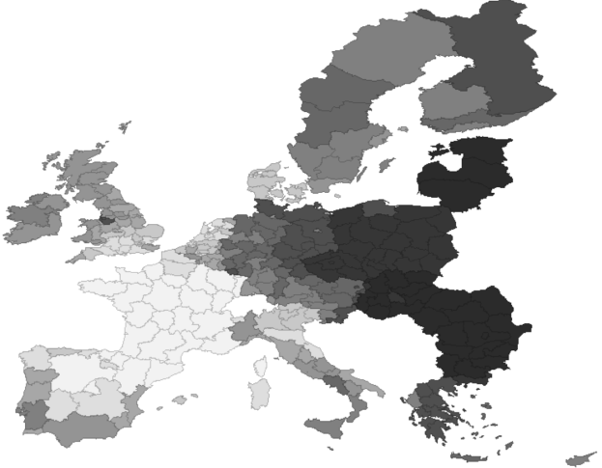 | 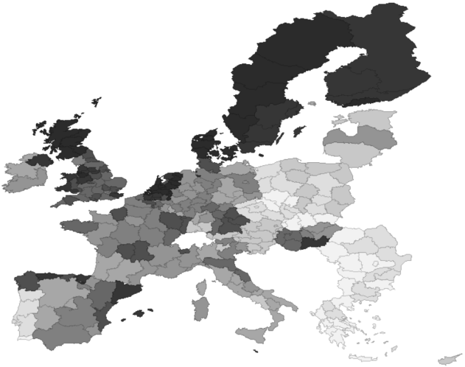

Source: own compilation

